# Appendix 2: Example scenarios

Four scenarios were mapped and analysed in more detail as examples. These are not intended to describe definitive solutions, but were selected as examples of good solutions:

I. Mothership model with 24 comprehensive stroke centres (CSC) providing intravenous thrombolysis (IVT) and endovascular thrombectomy (ET), where all patients attend their closest CSC. Locations based on the existing 24 neuroscience centres.

II. Mothership model with 30 CSCs providing IVT and ET, where patients attend closest centre. Locations based on using all 18 neuroscience centres outside of London, 4 London neuroscience centres, and 8 further centres that maximise the proportion of patients within 45 minutes of a CSC while keeping all admissions to hospitals above 1,500.

III. Drip n ship model with 30 CSCs as in scenario II. The location of 50 additional Hyper Acute Stroke Units (HASU) were selected in order to maximise the proportion of patients within 30 minutes of a HASU while keeping all the first admissions to hospitals in the range 600 to 2,00 per year. Patients first attend their closest unit regardless of type with onwards travel to CSC if patient requires endovascualr thrombectomy (ET). Show a map for IVT and for ET

IV. Drip n ship model with 30 CSCs and 50 HASUs as in scenario III, but with a 15 minute allowable delay to IVT to first attend a CSC in favour of a HASU, with onwards travel to CSC if patient requires endovascualr thrombectomy (ET).

A summary of the performance of the scenarios is shown below:

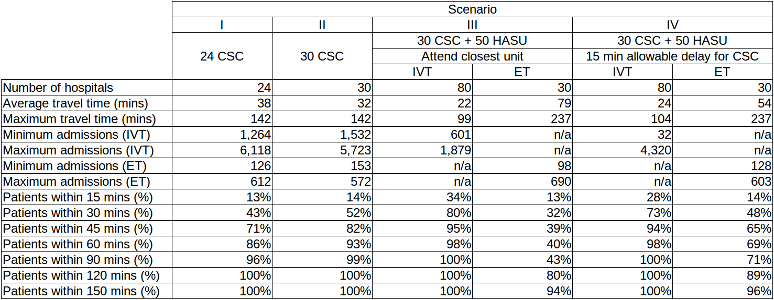

Map 1. Scenario 1 - Mothership model with 24 CSC: patient travel times and centre catchment areas for patients attending their closest centre.

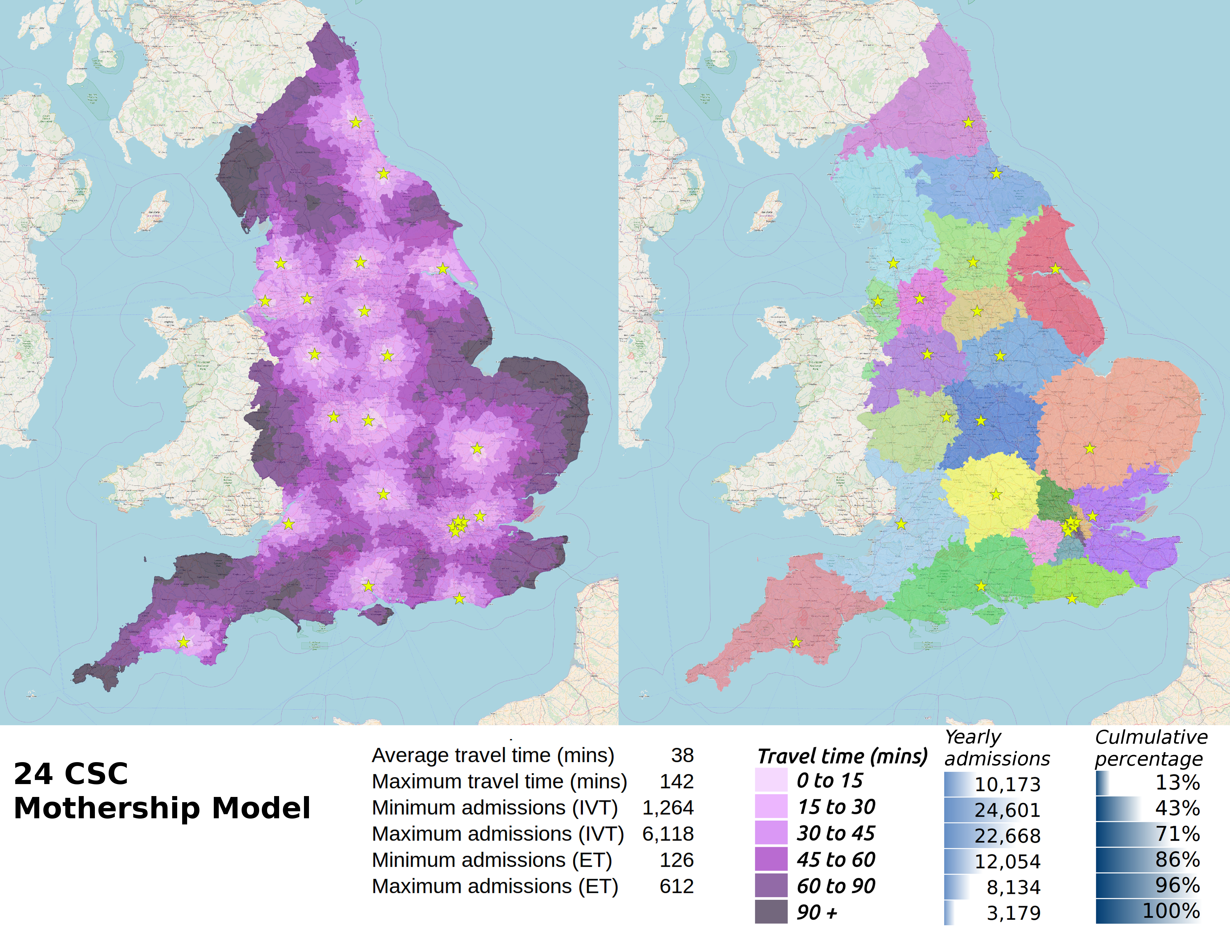

Map 2. Scenario 2 - Mothership model with 30 CSC: patient travel times and centre catchment areas for patients attending their closest centre.

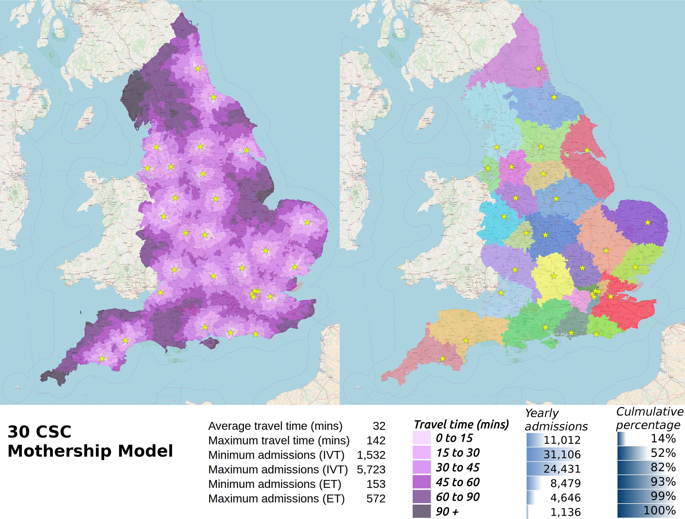

Map 3. Scenario 3 - Drip n ship model with 30 CSC and 50 HASU: patient travel times and centre catchment areas for patients attending first admitted centre (for IVT).

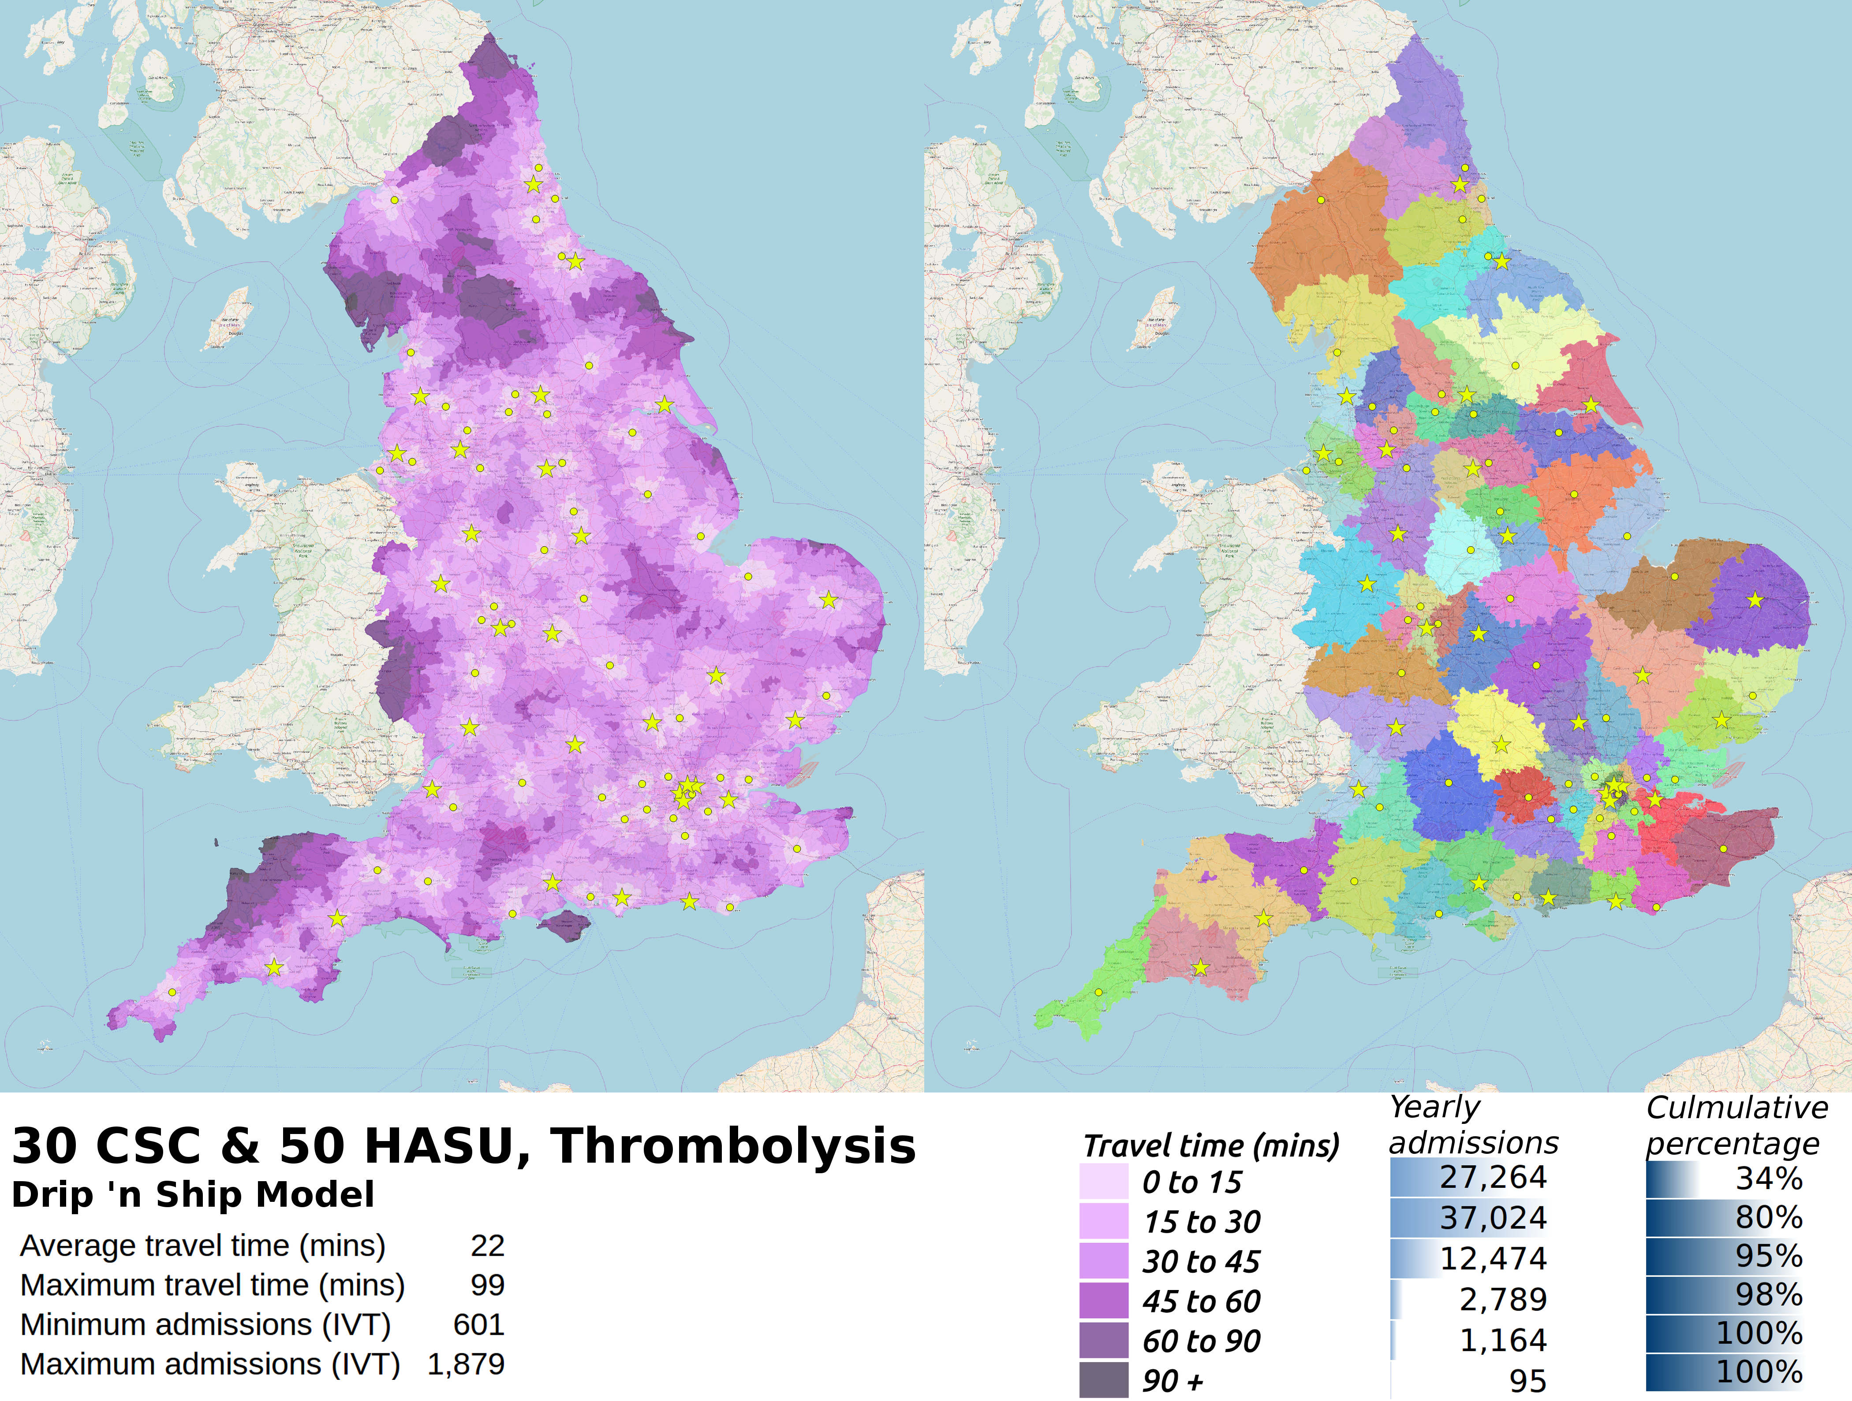

Map 4. Scenario 3 - Drip n ship model with 30 CSC and 50 HASU: patient travel times (including transfer & related delays) and CSC catchment areas for patients attending CSC for ET. Yellow stars show CSC locations, yellow dots show HASU locations.

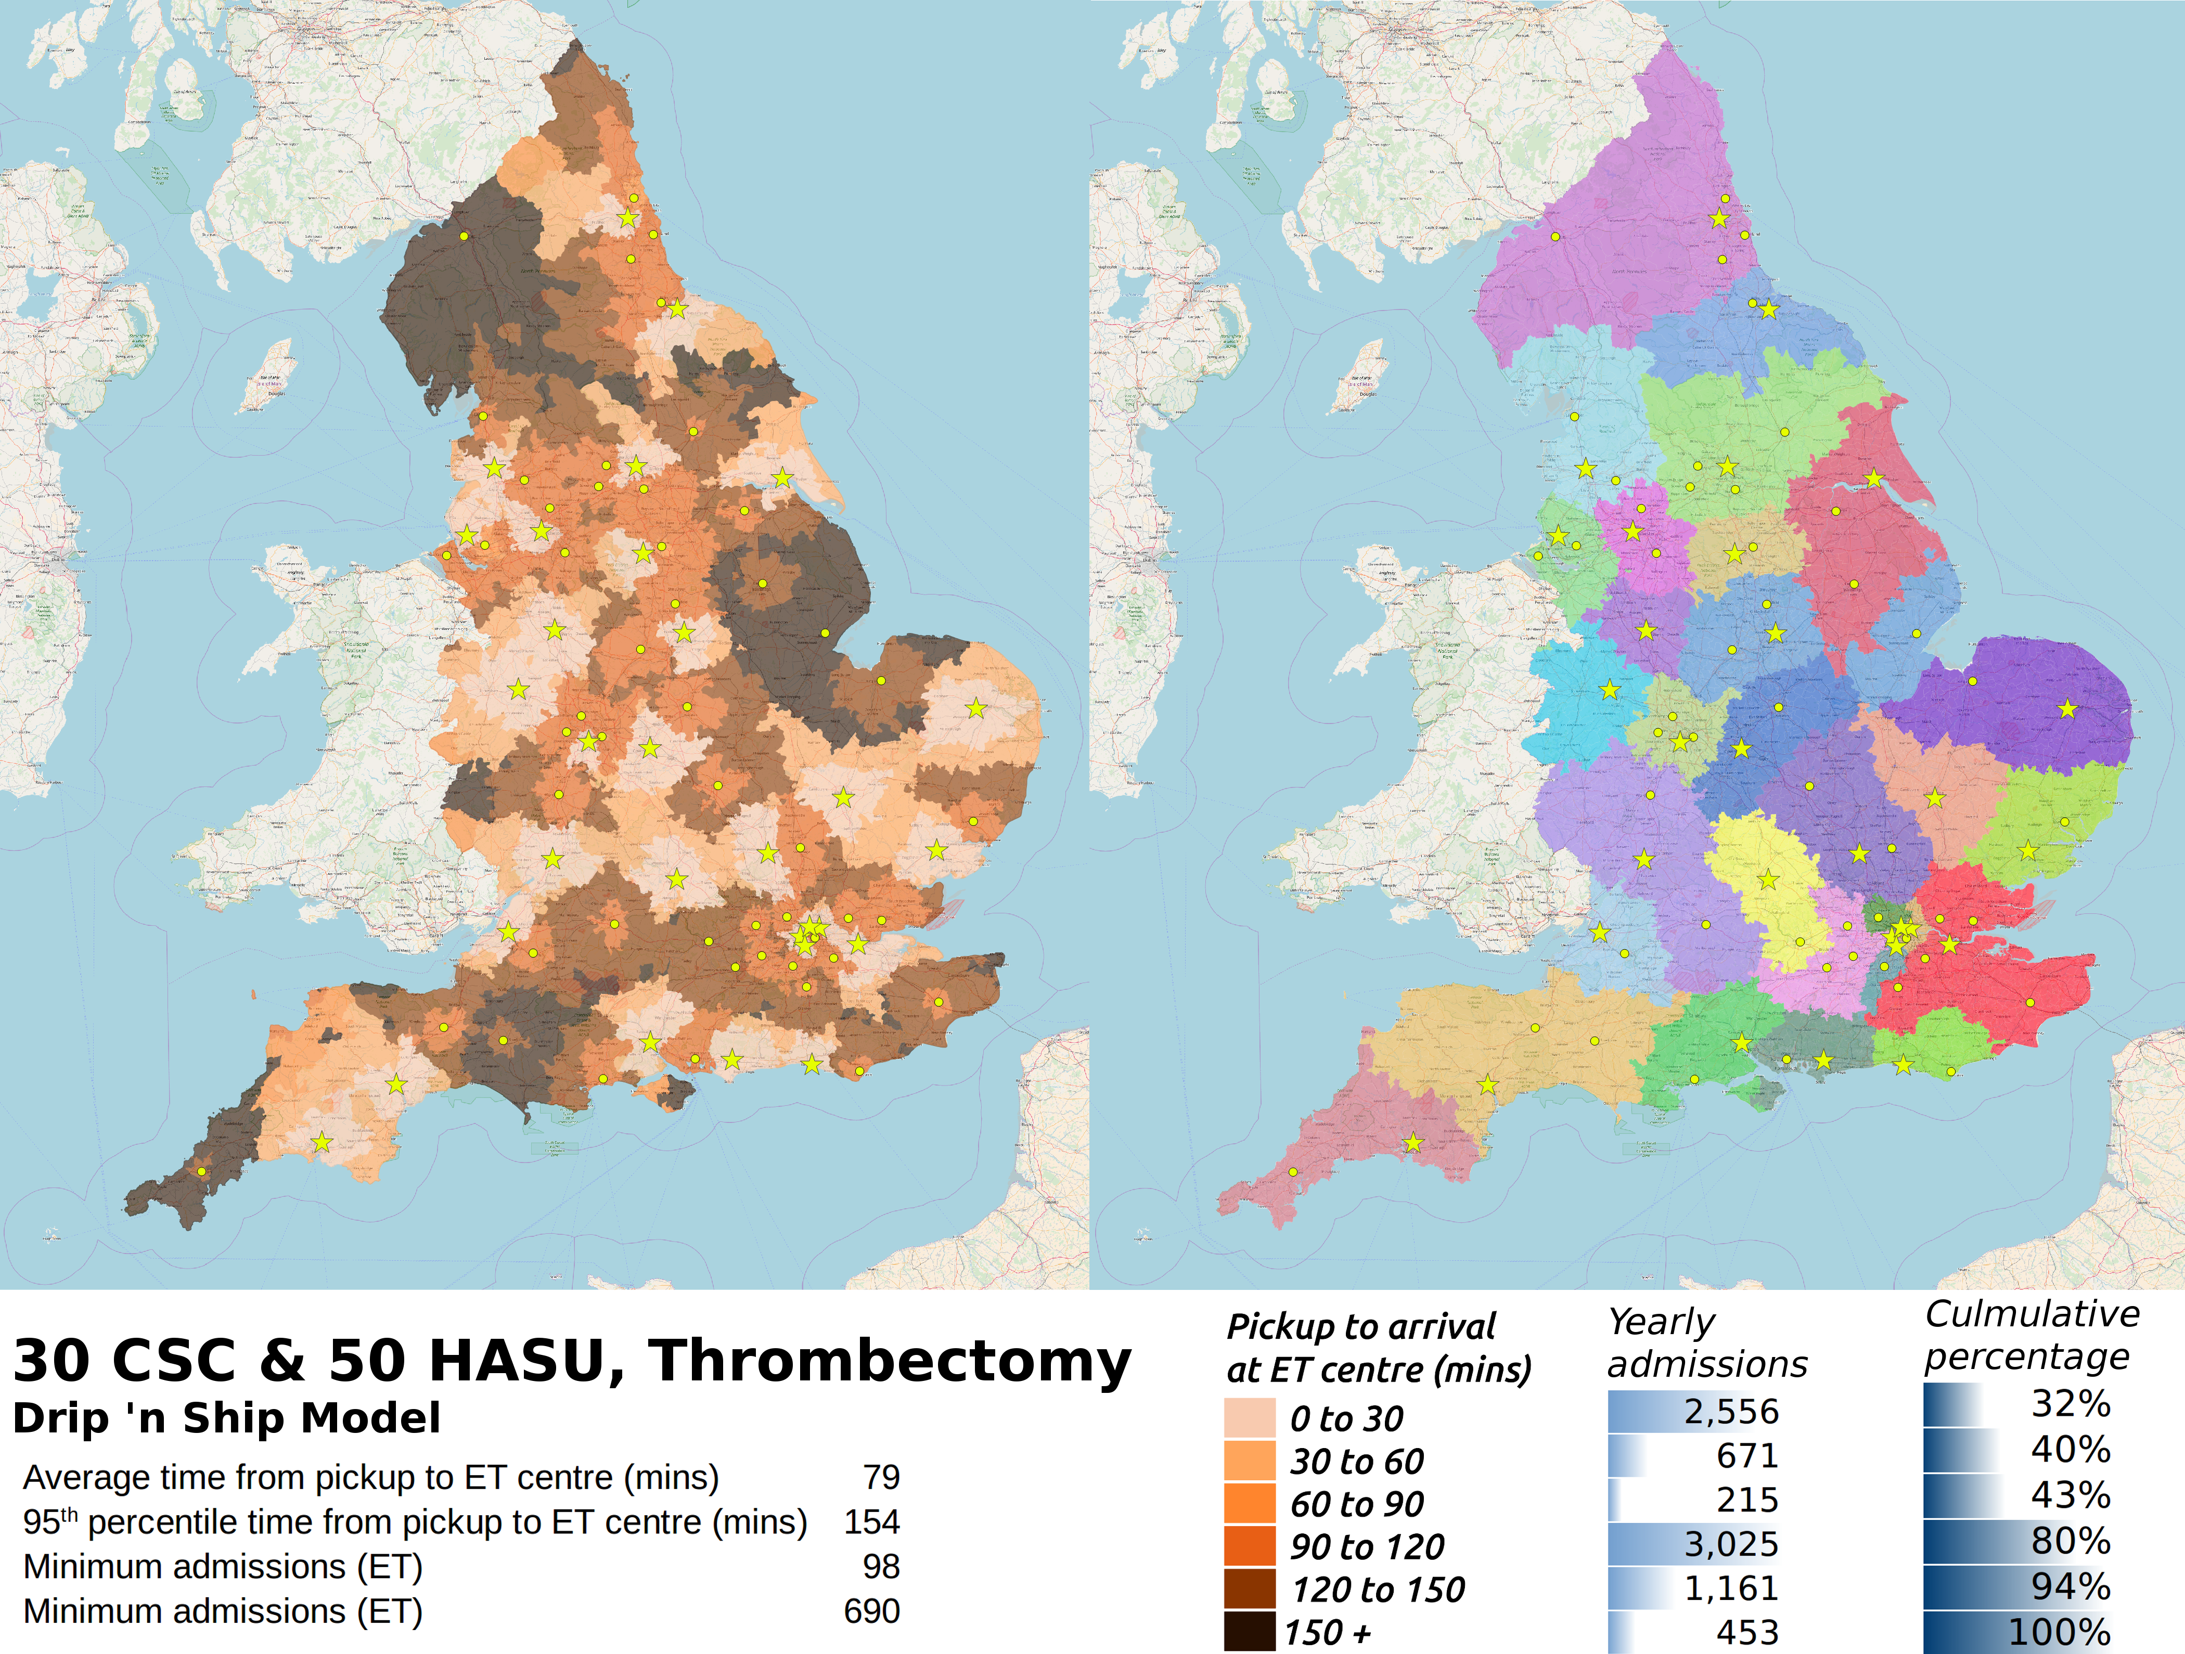

Map 5. Scenario 4 - Drip n ship model with 30 CSC and 50 HASU with a 15 minute allowable IVT delay: patient travel times and centre catchment areas for patients attending first admitted centre (for IVT).

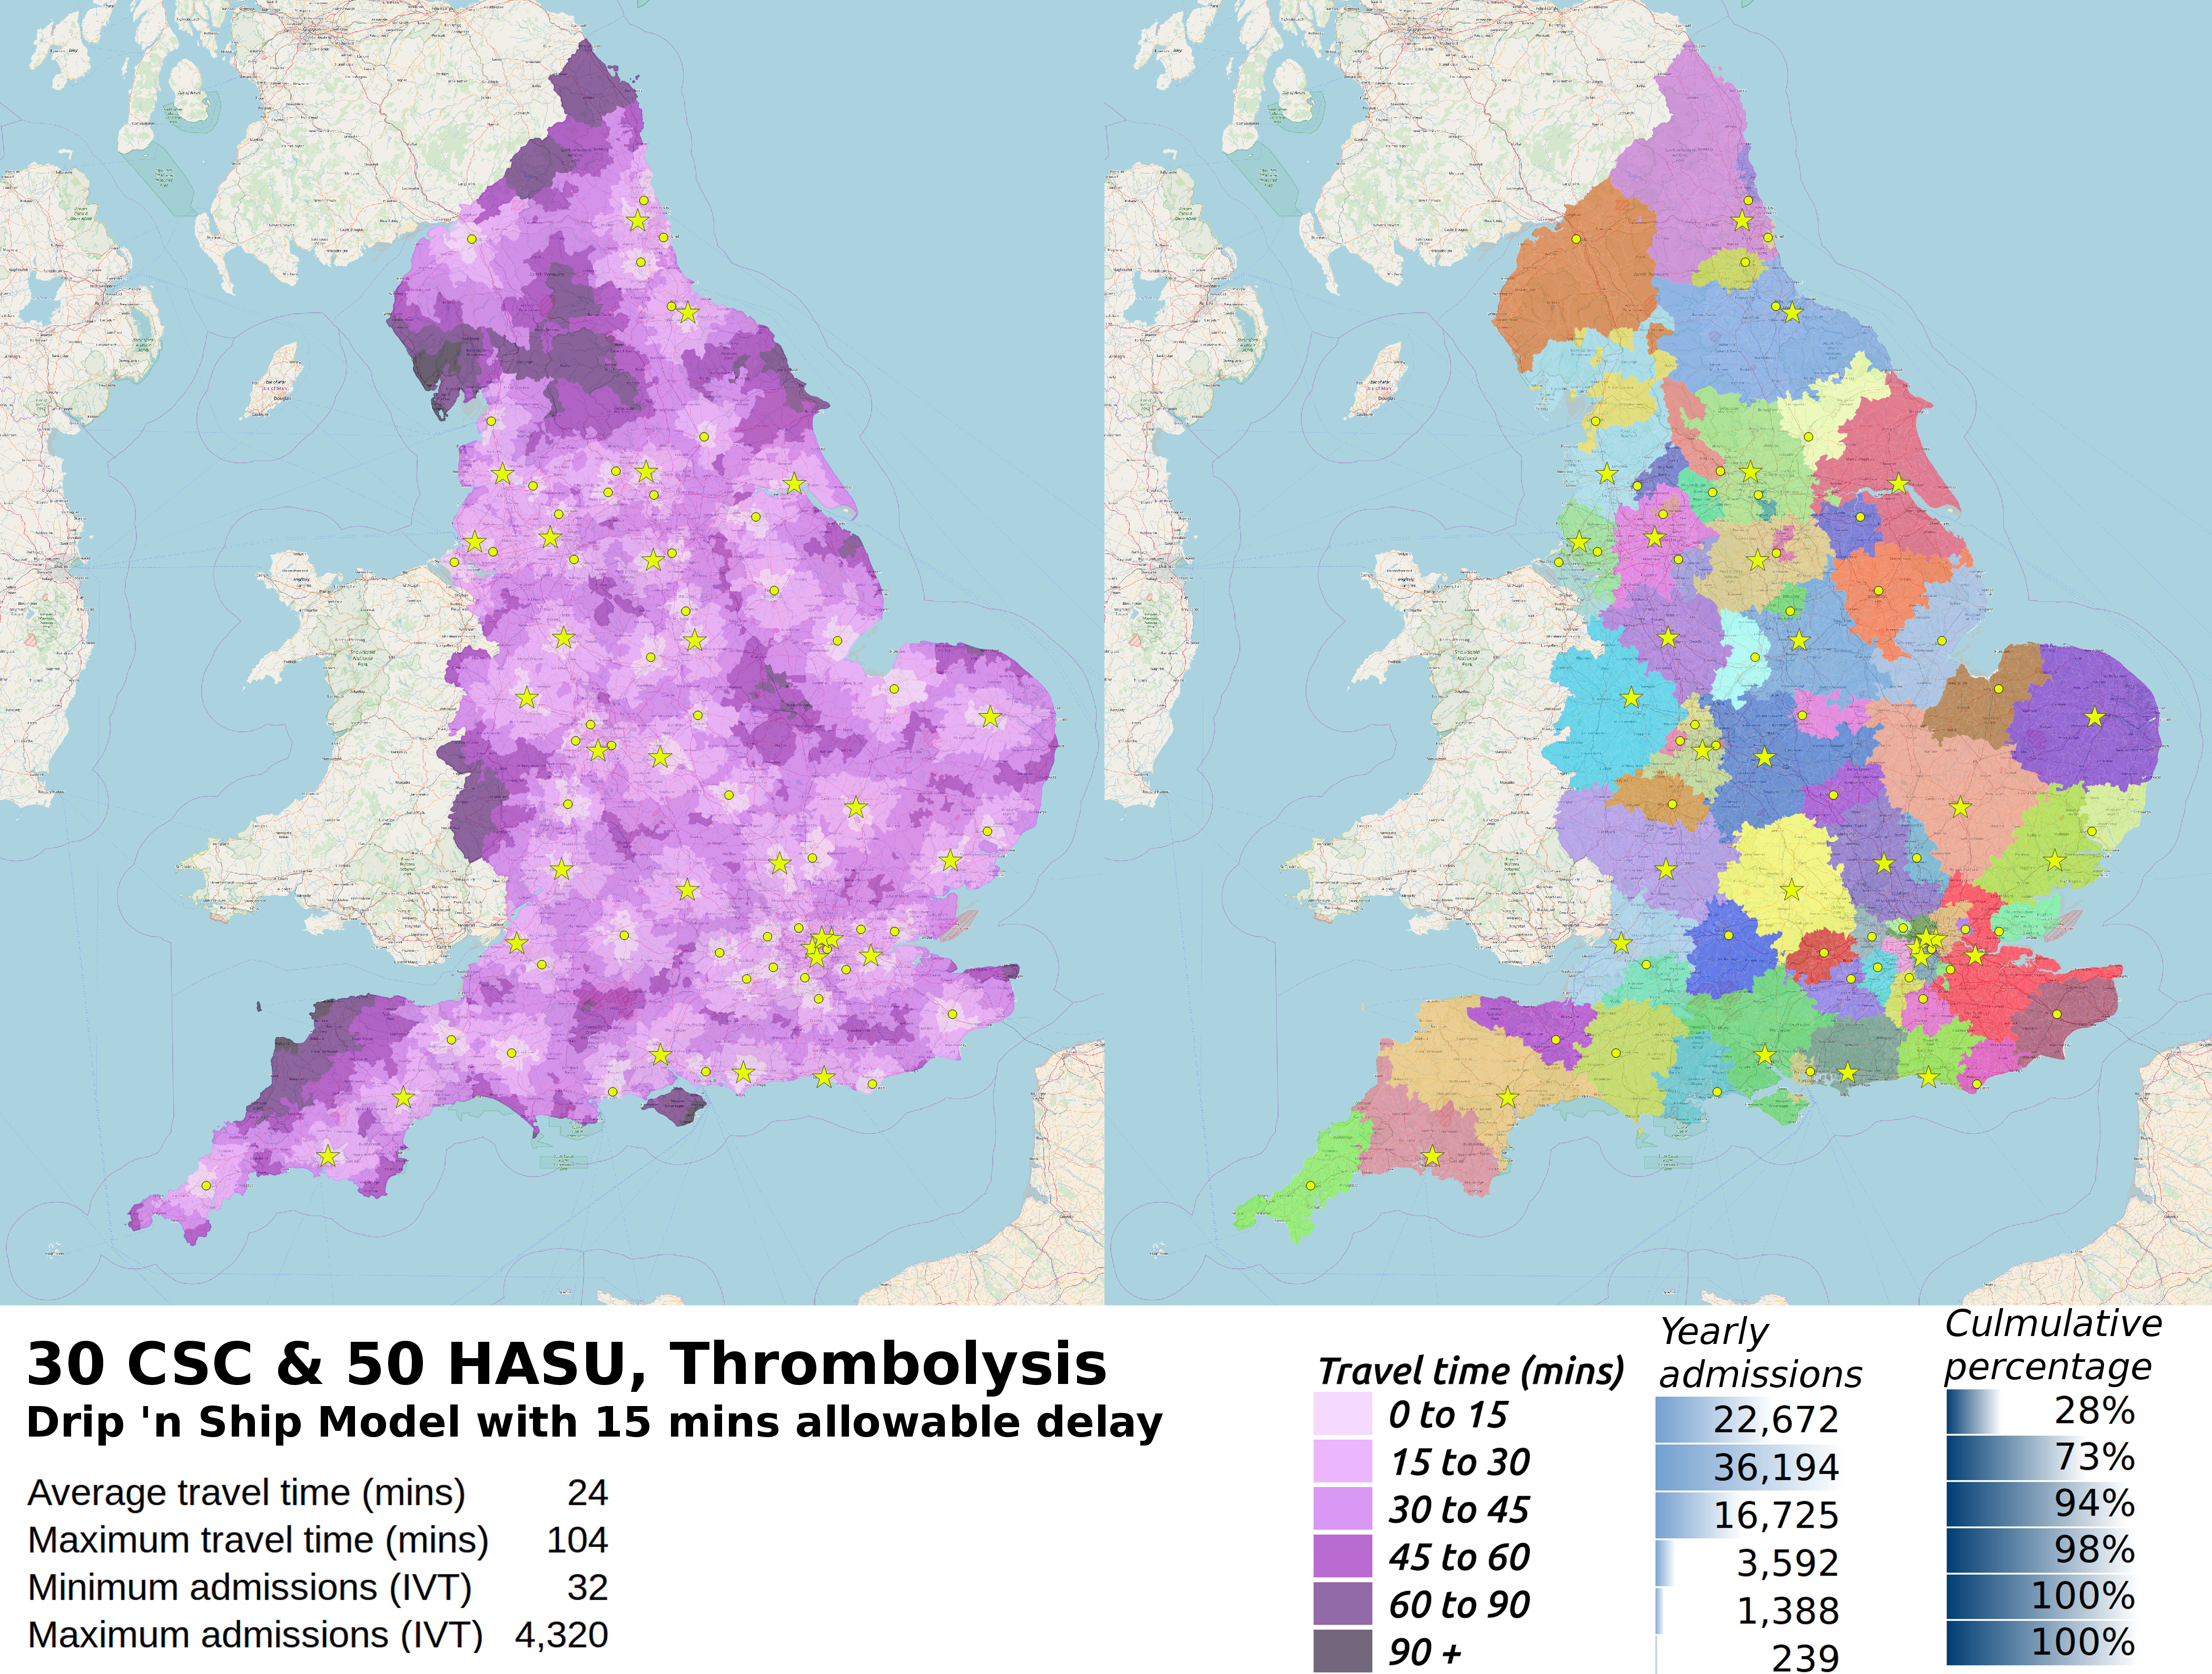

Map 6. Scenario 4 - Drip n ship model with 30 CSC and 50 HASU with 15 minute allowable IVT delay: patient travel times (including transfer & related delays) and CSC catchment areas for patients attending centre for ET. Yellow stars show CSC locations, yellow dots show HASU locations.

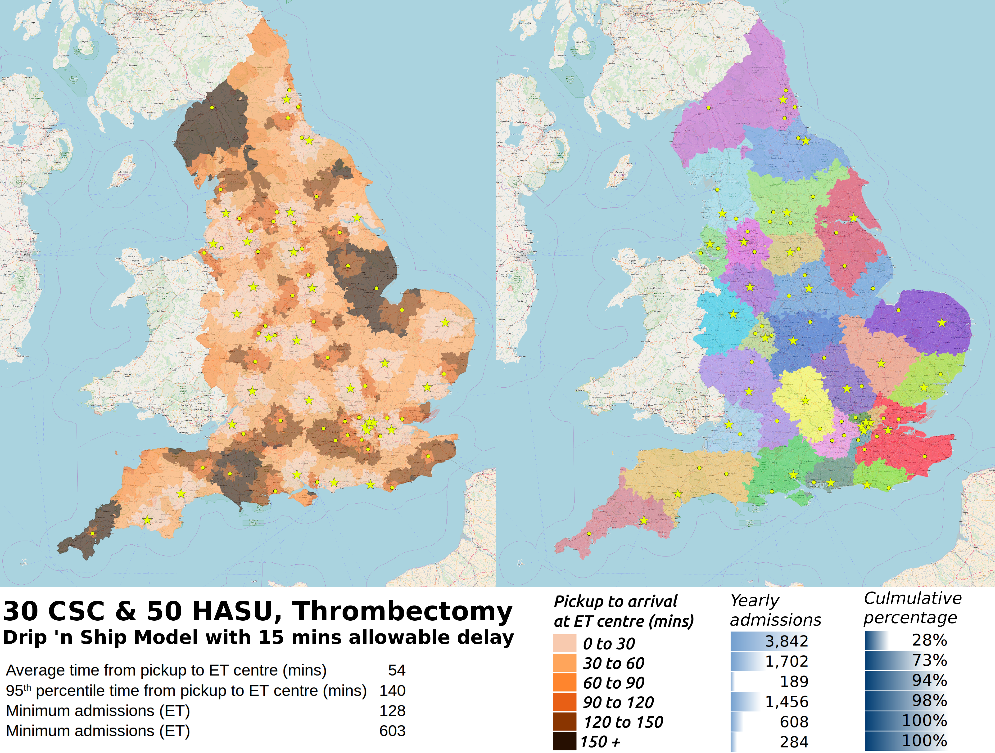

Figure 1. Arrival times to intravenous thrombolysis (IVT) and endovascular thrombectomy (ET) centres. The left panel shows percentile travel times to arrival at first admitting hospital (which is able to provide IVT if required). The right panel shows percentile travel times to an ET-capable centre. Four example scenarios are shown: I) 24 comprehensive stroke centres (CSC) providing IVT and ET where all patients attend closest centre, II) as (I) with 30 CSCs, III) 30 CSC and 50 hyper acute stroke centres (HASU) providing IVT-only, where all patents first attend closest centre with onwards travel to CSC if patient requires endovascular thrombectomy (ET), IV) as (III) but with an allowable IVT delay of 15 minutes.

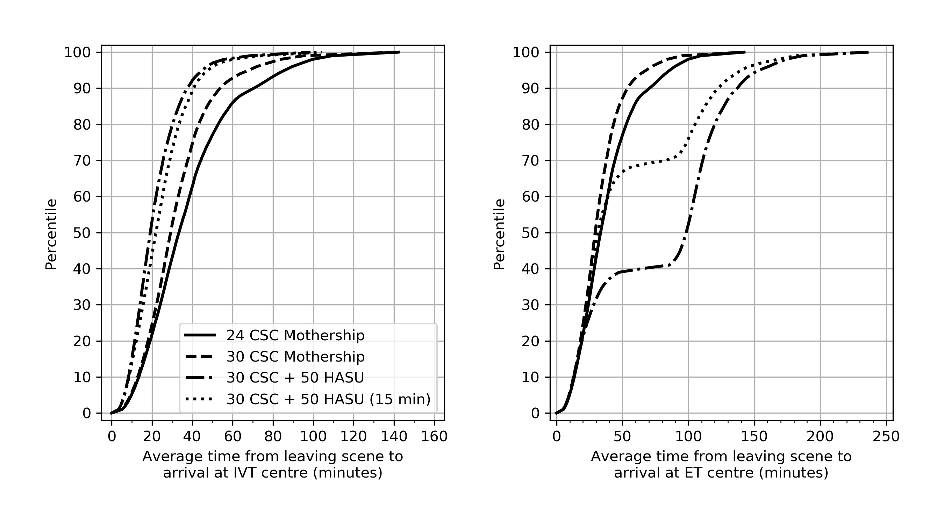

Figure 2. Hospital admissions per year at first admitting hospital (top panel) and ET centre (bottom panel). Four examples scenarios are shown: I) 24 comprehensive stroke centres (CSC) providing IVT and ET where all patients attend closest centre, II) as (I) with 30 CSCs, III) 30 CSC and 50 hyper acute stroke centres (HASU) providing IVT-only, where all patents first attend closest centre with onwards travel to CSC if patient requires endovascular thrombectomy (ET), IV) as (III) but with an allowable IVT delay of 15 minutes.

